Apache Iceberg

Lab 6: Create and populate Iceberg tables
Estimated completion time
- 30 minutes

Learning objectives
- In this lab, you will be introduced to the Iceberg table format and its many advantages. You will learn how to create Iceberg tables using Parquet and other file types, and explore how to create tables, add records, download results, and query values using Iceberg. You will also explore how conditional logic can be used to return precise results and how this is important for efficiency.

Prerequisites
- Student setup - Lab 1: Create student account

Activities
- Prepare for the exercise
- Create Iceberg tables using Parquet
- Research Iceberg connector documentation
- Create Iceberg table without defining format
- Add records to Iceberg table
- Simplify file list results
- Find distinct values
- Review documentation and list files
- Add additional records to table
- Add records using logical conditions

Step 1 - Prepare for the exercise
- Sign in and verify the students role is selected in the upper-right corner.
- Ensure the aws-us-east-1-free Cluster is reporting a Status of Running.
- In the Query editor, select aws-us-east-1-free in the cluster pulldown.

Note: If you did not previously create a schema, execute the following SQL statement. Make sure that you replace yourname with your actual name, or another identifier that you prefer. Only use lowercase characters and numbers; no special characters or spaces.

CREATE SCHEMA students.yourname;

Step 2 - Create Iceberg tables using Parquet
Create a new table in your schema named my_iceberg_tbl as shown below. Notice the WITH clause ensuring that it is created with the Iceberg type.

USE students.yourname;

CREATE TABLE my_iceberg_tbl (
id integer,
name varchar(55),
description varchar(255)
) WITH (
TYPE = 'iceberg', FORMAT = 'parquet'
);

Step 3 - Research Iceberg connector documentation
Reference the Iceberg connector — Starburst Enterprise metadata table documentation for this exercise. You will use several of these tables in this lab, and you can also explore others on your own that may not be utilized in these instructions.

Note: You will have to reference tables by their name only, not by their fully qualified 3-part catalog.schema.table name. Leverage the USE catalog.schema command or select appropriate values from the Select catalog and Select schema pulldowns in the upper-right of the UI.

Verify the file format type for this table.

SELECT * FROM "my_iceberg_tbl$properties";

Step 4 - Create Iceberg table without defining format
Create another table like the last one, but do not provide a file format in the WITH clause.

CREATE TABLE my_iceberg_tbl_dff (
id integer,
name varchar(55),
description varchar(255)
) WITH ( TYPE = 'iceberg' );

See what the $properties for this new table report was used for the default file format.

SELECT * FROM "my_iceberg_tbl_dff$properties";

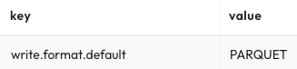

As shown above, the Parquet file format is the default file format.

Step 5 - Add records to Iceberg table
Add three new records to the table using the code below.

INSERT INTO my_iceberg_tbl
(id, name, description)
VALUES
(101, 'Leto', 'Ruler of House Atreides'),
(102, 'Jessica', 'Concubine of the Duke'),
(103, 'Paul', 'Son of Leto (aka Dale Cooper)');

Find out what file(s) these records are stored in.

SELECT
name,
"$path"
FROM
my_iceberg_tbl;

How many files are present? If it is hard to tell from the UI due to the long values for the $path special column, you could perform one or more of the following steps to help yourself.

Step 6 - Simply file list results
Trim down the value to only pick up after /data/ is found in the full path using the code below.

SELECT
name,
substring("$path", position('/data/' IN "$path") + 6)
FROM
my_iceberg_tbl;

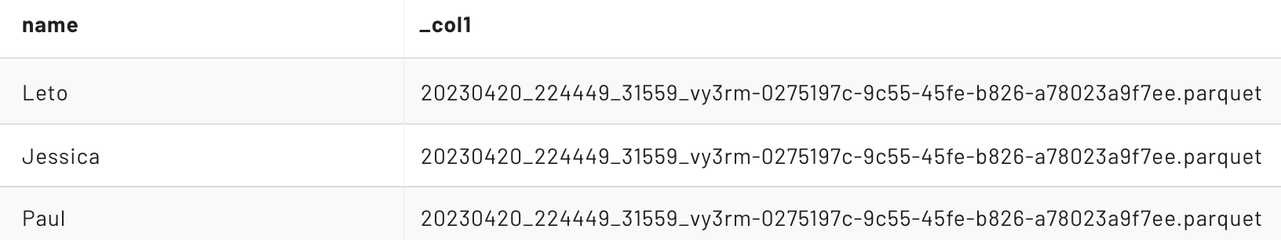

With a quick look, it should appear that all three of these records are referencing the same file on the data lake.

Step 7 - Find distinct values
Use the code below to return a list of distinct values.

SELECT
DISTINCT(substring("$path", position('/data/' IN "$path") + 6))
FROM
my_iceberg_tbl;

Verify you have a single Parquet file for the three records inserted.

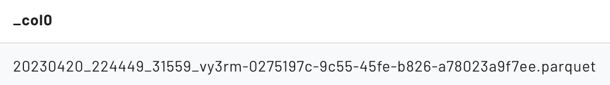

Step 8 - Review documentation and list files
Starburst Documentation outlines several ways to list the files corresponding to all of the rows in a table.

Review the material in the Iceberg connector — Starburst Enterprise section, and then query your table using the code below.

SELECT * FROM "my_iceberg_tbl$files";

You should see a single file – the same one from Step 7. Return specific fields for deeper review.

SELECT
substring(file_path, position('/data/' IN file_path) + 6),
record_count,
value_counts,
null_value_counts,
lower_bounds,
upper_bounds
FROM
"my_iceberg_tbl$files";

Column | Value | Notes
file_path | 20221224...shortened...f6e3.parquet | A specific file name. The remainder of the columns relate to this particular file
record_count | 3 | There are 3 records in the file
value_counts | { 1 = 3, 2 = 3, 3 = 3 } | Each of the 3 columns has 3 values
null_value_counts | { 1 = 0, 2 = 0, 3 = 0 } | None of the columns have any null values present
lower_bounds | { 1 = 101, 2 = Jessica, 3 = Wife of the } | > The id field ranges from 101 to 103  > The name field ranges from Jessica to Paul  > The description field ranges from Wife to Son…
upper_bounds | { 1 = 103, 2 = Paul, 3 = Son of Leto }

Step 9 - Add additional records to table
Add a few more rows.

INSERT INTO my_iceberg_tbl
(id, name, description)
VALUES
(104, 'Thufir', 'Mentat'),
(201, 'Vladimir', 'Ruler of House Harkonnen'),
(202, 'Rabban', 'Ruthless nephew of Vladimir'),
(203, 'Feyd-Rautha', 'Savvy nephew of Vladimir (played by Sting)'),
(301, 'Reverend Mother Gaius Helen Mohiam', null);

Run the $files query again from Step 8 and review your findings from the new data file just created.

Column | Value | Notes
file_path | 20221224...shortened...g2m3e.parquet | A specific file name. The remainder of the columns relate to this particular file
record_count | 5 | There are 3 records in the file
value_counts | { 1 = 5, 2 = 5, 3 = 5 } | Each of the 3 columns has 5 values
null_value_counts | { 1 = 0, 2 = 0, 3 = 1 } | One of the rows has a null for the description field
lower_bounds | { 1 = 104, 2 = Feyd-Rautha, 3 = Mentat } | > The id field ranges from 104 to 301  > The name field ranges from Feyd-Rautha to Vladimir  > The description field ranges from Mentat to Savy nephew…
upper_bounds | { 1 = 301, 2 = Vladimir, 3 = Savvy nephew of! }

END OF LAB EXERCISE

